Cryptography
Cryptography is the practice of securing information by transforming it into an unreadable format to prevent unauthorized access. It involves techniques that ensure data privacy, integrity, and authentication. The core idea is to encrypt (scramble) sensitive information, which can only be decrypted (unscrambled) by someone with the right key.

Plain Text
Plain text refers to the original, unencrypted information or message that is readable by humans or systems. It is the input that will be encrypted using cryptographic algorithms.

Cipher Text
Cipher text is the output of encryption. It is the scrambled, unreadable version of the plain text that cannot be understood without the decryption key. The cipher text protects the information from being accessed by unauthorized individuals.
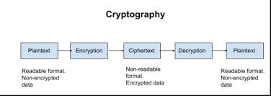
For example:
- Plain Text: "Hello World"
- Cipher Text: "Khoor Zruog" (using substitution to the shift of 3)
In cryptography, encryption and decryption are the fundamental processes used to secure data:
- Encryption is the process of converting plain, readable information (plaintext) into a coded, unreadable form (ciphertext) to protect the data from unauthorized access. This process uses an algorithm and an encryption key to scramble the data.

- Decryption is the reverse process of encryption, where the encrypted ciphertext is converted back into its original readable form (plaintext). This process also uses a key (which may or may not be the same as the encryption key, depending on the encryption technique) to restore the original information

- Simple Columnar Transposition:
It is a technique in which the plain text is written row by row in a grid of fixed column size (based on the key), and the cipher text is formed by reading the grid column by column. The order of the columns can also be rearranged according to a numeric key for extra security, but in this case, we use a simple fixed columnar structure. This method maintains the same characters but rearranges them into a different order, making it difficult to read without the proper key.

Example:
- Write the plaintext message in a grid, filling in the letters row by row. For this example, let’s use the message:
HELLO WORLD
- Choose a key that determines how you’ll rearrange the columns. Let’s say the key is 4312.
- Arrange the message in rows under the key columns. Use spaces to fill any empty cells.
4 | 3 | 1 | 2
H | E | L | L
O | W | O | R
L | D
- Read the columns based on the key. According to the key order (4, 3, 1, 2), we read the columns in this order:
  - Column 1 (key 4): L, R, (blank)
  - Column 2 (key 3): O, O, (blank)
  - Column 3 (key 1): H, O, L
  - Column 4 (key 2): E, W, D
So, the ciphertext becomes: LR OO HOL EWD

Algorithm for Simple Columnar Transposition (Used in this Program)

Encryption Algorithm:
- Input: Plain text and a numeric key (indicating the number of columns).
- Grid Creation: Arrange the plain text row by row in a grid with a number of columns equal to the key. If the text doesn’t fit exactly, pad the remaining cells with spaces.
- Form Cipher Text: Read the text column by column (top to bottom, left to right) to form the cipher text.
- Output: The cipher text.

Decryption Algorithm:
- Input: Cipher text and a numeric key (indicating the number of columns).
- Grid Creation: Arrange the cipher text column by column in a grid with a number of columns equal to the key.
- Form Plain Text: Read the text row by row (left to right) to recover the original plain text.
- Output: The plain text.

Monoalphabetic Cipher
In a monoalphabetic cipher, each letter of the plaintext is replaced by a unique corresponding letter in the ciphertext. This cipher uses a fixed substitution scheme, where one letter maps to another, and the same letter will always be replaced by the same cipher letter throughout the entire message.

Example of Monoalphabetic Cipher
- Plaintext: HELLO
- Key/Substitution Map:
  - A -> M, B -> N, C -> O, D -> P, E -> Q, F -> R, G -> S, H -> T, I -> U, J -> V, K -> W, L -> X, M -> Y, N -> Z, O -> A, P -> B, Q -> C, R -> D, S -> E, T -> F, U -> G, V -> H, W -> I, X -> J, Y -> K, Z -> L.
This key substitutes each letter of the alphabet with another one.
- Ciphertext:
  - H -> T
  - E -> Q
  - L -> X
  - L -> X
  - O -> A
So, the ciphertext for "HELLO" is TQXXA.

Algorithm (Monoalphabetic Cipher)
Encryption Algorithm:
- Input: Plain text and a substitution alphabet or key.
- Create Substitution Mapping: Map each letter in the plain alphabet to the substitution alphabet.
- Encrypt Each Character: For each letter in the plain text, replace it with the corresponding letter from the substitution alphabet.
- Output: Cipher text.

Decryption Algorithm:
- Input: Cipher text and a substitution alphabet.
- Create Reverse Mapping: Map each letter in the substitution alphabet back to the plain alphabet.
- Decrypt Each Character: For each letter in the cipher text, replace it with the corresponding letter from the reverse mapping.
- Output: Plain text.

Reverse Cipher
The Reverse Cipher is a simple and symmetric encryption technique where the characters of the plain text are reversed to form the cipher text. This method doesn't use a key, and encryption and decryption use the same process of reversing the string.

Example:
- Plain Text: HELLO
- Cipher Text (Encrypted Text): OLLEH
- Cipher Text: OLLEH
- Plain Text (Decrypted Text): HELLO

Encryption Algorithm:
- Input: Plain text string.
- Reversal: Reverse the order of the characters in the plain text.
- Output: The reversed string becomes the cipher text.

Decryption Algorithm:
- Input: Cipher text string (which is a reversed plain text).
- Reversal: Reverse the order of the characters in the cipher text to restore the original plain text.
- Output: The original plain text.
Since the same process is used for both encryption and decryption, this algorithm is symmetric.

Predefined Function in Java:
In Java, the StringBuilder class provides a reverse() method that can be used to reverse the string for both encryption and decryption.

Encryption and Decryption Function (Java Code):

private String reverseMessage(String text) {
return new StringBuilder(text).reverse().toString();
}
This single method works for both encryption and decryption since reversing the string twice restores the original text.
- Explanation:
  - The StringBuilder class in Java allows you to manipulate and modify strings.
  - The reverse() method reverses the sequence of characters in the string.
  - The toString() method converts the StringBuilder object back to a String.

Acrostic Steganography
Acrostic Steganography is a method of hiding a secret message within a cover text by taking the first letters of a series of words to form the hidden message. The cover text appears normal, but by extracting the first letters of each word, the hidden message (plain text) can be retrieved.
This method is different from traditional cryptography as it hides information in plain sight (steganography), rather than altering the text to make it unreadable.

Example:
- Plain Text (Secret Message): HELLO
- Cover Text:
markdown
Copy code
**H**appy **E**lephants **L**ove **L**arge **O**ranges.
- Cipher Text (Generated Cover Text): Happy, Elephants Love Large Oranges.
  - The first letters of the cover text words, when read together, form the secret message "HELLO."

Encryption Algorithm:
- Input: Plain text (message to be hidden) and a set of words for the cover text.
- Step 1: For each character in the plain text, find or create a word in the cover text that starts with that character. (Optional: Use predefined words such as "Apple" for 'A', "Ball" for 'B', etc.).
- Step 2: Form the cover text by placing these words in sequence.
- Output: The generated cover text, where the hidden message is encoded in the first letters of each word.

Decryption Algorithm:
- Input: Cover text.
- Step 1: Extract the first letter from each word in the cover text.
- Step 2: Combine these letters to form the hidden message (plain text).
- Output: The extracted plain text message.

Program Code: EncryptionDecryptionSystem.java
import javax.swing.*;
import java.awt.*;
import java.awt.event.*;

public class EncryptionDecryptionSystem
{
private JFrame mainFrame;

public EncryptionDecryptionSystem()
{
mainFrame = new JFrame("Encryption and Decryption System");
mainFrame.setSize(700, 400);
mainFrame.setDefaultCloseOperation(JFrame.EXIT_ON_CLOSE);
mainFrame.setLayout(new BorderLayout());

JLabel titleLabel = new JLabel("Encryption and Decryption System", SwingConstants.CENTER);
titleLabel.setFont(new Font("Arial", Font.BOLD, 20));
mainFrame.add(titleLabel, BorderLayout.NORTH);

JPanel buttonPanel = new JPanel();
buttonPanel.setLayout(new FlowLayout());

JButton encryptButton = new JButton("Encryption");
JButton decryptButton = new JButton("Decryption");

encryptButton.setBackground(Color.CYAN);
decryptButton.setBackground(Color.LIGHT_GRAY);

buttonPanel.add(encryptButton);
buttonPanel.add(decryptButton);

mainFrame.add(buttonPanel, BorderLayout.CENTER);

encryptButton.addActionListener(new ActionListener()
{
public void actionPerformed(ActionEvent e) {
mainFrame.dispose();
showEncryptionFrame();
}
});

decryptButton.addActionListener(new ActionListener() {
public void actionPerformed(ActionEvent e) {
mainFrame.dispose();
showDecryptionFrame();
}
});

mainFrame.setVisible(true);
}

private void showEncryptionFrame() {
JFrame encryptionFrame = new JFrame("Encryption");
encryptionFrame.setSize(700, 500);
encryptionFrame.setDefaultCloseOperation(JFrame.EXIT_ON_CLOSE);
encryptionFrame.setLayout(new GridLayout(7, 2, 10, 10));

JLabel plainTextLabel = new JLabel("Plain Text:");
JTextField plainTextField = new JTextField();
plainTextField.setBackground(Color.WHITE);

JLabel keyLabel = new JLabel("Key (if applicable):");
JTextField keyField = new JTextField();
keyField.setBackground(Color.WHITE);

JLabel cipherTextLabel = new JLabel("Cipher Text:");
JTextField cipherTextField = new JTextField();
cipherTextField.setEditable(false);
cipherTextField.setBackground(Color.LIGHT_GRAY);

JPanel radioPanel = new JPanel();
radioPanel.setLayout(new GridLayout(1, 4));
JRadioButton monoAlphabetic = new JRadioButton("Monoalphabetic");
JRadioButton reversible = new JRadioButton("Reversible");
JRadioButton acrosticSteg = new JRadioButton("Acrostic Steganography");
JRadioButton simpleColumnar = new JRadioButton("Simple Columnar");

ButtonGroup group = new ButtonGroup();
group.add(monoAlphabetic);
group.add(reversible);
group.add(acrosticSteg);
group.add(simpleColumnar);

radioPanel.add(monoAlphabetic);
radioPanel.add(reversible);
radioPanel.add(acrosticSteg);
radioPanel.add(simpleColumnar);

JButton encryptButton = new JButton("Encrypt");
encryptButton.setBackground(Color.GREEN);

JButton backButton = new JButton("Back");
backButton.setBackground(Color.ORANGE);
backButton.addActionListener(new ActionListener() {
public void actionPerformed(ActionEvent e) {
encryptionFrame.dispose();
new EncryptionDecryptionSystemDummy();
}
});

encryptionFrame.add(plainTextLabel);
encryptionFrame.add(plainTextField);
encryptionFrame.add(keyLabel);
encryptionFrame.add(keyField);
encryptionFrame.add(cipherTextLabel);
encryptionFrame.add(cipherTextField);
encryptionFrame.add(new JLabel("Encryption Method:"));
encryptionFrame.add(radioPanel);
encryptionFrame.add(new JLabel());
encryptionFrame.add(encryptButton);
encryptionFrame.add(new JLabel());
encryptionFrame.add(backButton);

encryptionFrame.setVisible(true);

encryptButton.addActionListener(new ActionListener(){
@Override
public void actionPerformed(ActionEvent e) {
String plainText = plainTextField.getText().trim();
String key = keyField.getText().trim();
String cipherText = "";

if (plainText.isEmpty()) {
JOptionPane.showMessageDialog(encryptionFrame, "Plain text is required!", "Error", JOptionPane.ERROR_MESSAGE);
return;
}

if (!monoAlphabetic.isSelected() && !reversible.isSelected() && !acrosticSteg.isSelected() && !simpleColumnar.isSelected()) {
JOptionPane.showMessageDialog(encryptionFrame, "Please choose a method!", "Error", JOptionPane.ERROR_MESSAGE);
return;
}

if (monoAlphabetic.isSelected()) {
if (!key.matches("\\d") || key.length() != 1) {
JOptionPane.showMessageDialog(encryptionFrame, "Key for Monoalphabetic must be a single digit!", "Error", JOptionPane.ERROR_MESSAGE);
return;
}
cipherText = monoalphabeticSubstitution(plainText, key);
}
else if (reversible.isSelected())
{
cipherText = reverseMessage(plainText);
} else if (acrosticSteg.isSelected())
{
if (!key.matches("[A-Za-z]+") || key.length() != plainText.length())
{
JOptionPane.showMessageDialog(encryptionFrame, "Key for Acrostic Steganography must be alphabetic and match the plain text length!", "Error", JOptionPane.ERROR_MESSAGE);
return;
}
cipherText = acrosticSteganography(plainText, key);
} else if (simpleColumnar.isSelected()) {
if (!key.matches("\\d+")) {
JOptionPane.showMessageDialog(encryptionFrame, "Key for Simple Columnar must be numeric!", "Error", JOptionPane.ERROR_MESSAGE);
return;
}
cipherText = simpleColumnarTransposition(plainText, key);
}

cipherTextField.setText(cipherText);
}
});
}

private String monoalphabeticSubstitution(String plainText, String key) {
StringBuilder cipherText = new StringBuilder();
int shift = key.isEmpty() ? 3 : Integer.parseInt(key) % 26;
for (char ch : plainText.toCharArray()) {
if (Character.isLetter(ch)) {
char base = Character.isUpperCase(ch) ? 'A' : 'a';
cipherText.append((char) ((ch - base + shift) % 26 + base));
} else {
cipherText.append(ch);
}
}
return cipherText.toString();
}

private String reverseMessage(String plainText) {
return new StringBuilder(plainText).reverse().toString();
}
private String acrosticSteganography(String plainText, String key) {
String[] words = {
"Apple", "Ball", "Cat", "Dog", "Elephant", "Fish", "Giraffe",
"Hat", "Ice", "Jug", "Kite", "Lion", "Monkey", "Nest", "Orange",
"Penguin", "Queen", "Rabbit", "Snake", "Tiger", "Umbrella",
"Violin", "Whale", "Xylophone", "Yacht", "Zebra"
};

StringBuilder cipherText = new StringBuilder();

for (char c : plainText.toCharArray()) {
if (Character.isLetter(c)) {
int index = Character.toLowerCase(c) - 'a';
if (index >= 0 && index < words.length) {
cipherText.append(words[index]).append(" ");
}
} else {
cipherText.append(c).append(" ");
}
}
return cipherText.toString().trim();
}

private String acrosticDecryption(String cipherText) {
StringBuilder plainText = new StringBuilder();
String[] words = cipherText.split(" ");

for (String word : words) {
if (!word.isEmpty()) {
char firstChar = word.charAt(0);
plainText.append(firstChar);
}
}
return plainText.toString();
}

private String simpleColumnarTransposition(String plainText, String key) {
int columns = key.isEmpty() ? 3 : Integer.parseInt(key);
StringBuilder cipherText = new StringBuilder();
int rows = (int) Math.ceil((double) plainText.length() / columns);

char[][] table = new char[rows][columns];
for (int i = 0; i < rows; i++) {
for (int j = 0; j < columns; j++) {
int index = i * columns + j;
if (index < plainText.length()) {
table[i][j] = plainText.charAt(index);
} else {
table[i][j] = ' '; }
}
}

for (int j = 0; j < columns; j++) {
for (int i = 0; i < rows; i++) {
cipherText.append(table[i][j]);
}
}
return cipherText.toString();
}

private void showDecryptionFrame(){
JFrame decryptionFrame = new JFrame("Decryption");
decryptionFrame.setSize(700, 500);
decryptionFrame.setDefaultCloseOperation(JFrame.EXIT_ON_CLOSE);
decryptionFrame.setLayout(new GridLayout(7, 2, 10, 10));

JLabel cipherTextLabel = new JLabel("Cipher Text:");
JTextField cipherTextField = new JTextField();
cipherTextField.setBackground(Color.WHITE);

JLabel keyLabel = new JLabel("Key (if applicable):");
JTextField keyField = new JTextField();
keyField.setBackground(Color.WHITE);

JLabel plainTextLabel = new JLabel("Plain Text:");
JTextField plainTextField = new JTextField();
plainTextField.setEditable(false);
plainTextField.setBackground(Color.LIGHT_GRAY);

JPanel radioPanel = new JPanel();
radioPanel.setLayout(new GridLayout(1, 4));
JRadioButton monoAlphabetic = new JRadioButton("Monoalphabetic");
JRadioButton reversible = new JRadioButton("Reversible");
JRadioButton acrosticSteg = new JRadioButton("Acrostic Steganography");
JRadioButton simpleColumnar = new JRadioButton("Simple Columnar");

ButtonGroup group = new ButtonGroup();
group.add(monoAlphabetic);
group.add(reversible);
group.add(acrosticSteg);
group.add(simpleColumnar);

radioPanel.add(monoAlphabetic);
radioPanel.add(reversible);
radioPanel.add(acrosticSteg);
radioPanel.add(simpleColumnar);

JButton decryptButton = new JButton("Decrypt");
decryptButton.setBackground(Color.RED);

JButton backButton = new JButton("Back");
backButton.setBackground(Color.ORANGE);
backButton.addActionListener(new ActionListener() {
public void actionPerformed(ActionEvent e)
{
decryptionFrame.dispose();
new EncryptionDecryptionSystemDummy();
}
});

decryptionFrame.add(cipherTextLabel);
decryptionFrame.add(cipherTextField);
decryptionFrame.add(keyLabel);
decryptionFrame.add(keyField);
decryptionFrame.add(plainTextLabel);
decryptionFrame.add(plainTextField);
decryptionFrame.add(new JLabel("Decryption Method:"));
decryptionFrame.add(radioPanel);
decryptionFrame.add(new JLabel());
decryptionFrame.add(decryptButton);
decryptionFrame.add(new JLabel());
decryptionFrame.add(backButton);

decryptionFrame.setVisible(true);

decryptButton.addActionListener(new ActionListener() {
@Override
public void actionPerformed(ActionEvent e) {
String cipherText = cipherTextField.getText().trim();
String key = keyField.getText().trim();
String plainText = "";

if (cipherText.isEmpty()) {
JOptionPane.showMessageDialog(decryptionFrame, "Cipher text is required!", "Error", JOptionPane.ERROR_MESSAGE);
return;
}

if (!monoAlphabetic.isSelected() && !reversible.isSelected() && !acrosticSteg.isSelected() && !simpleColumnar.isSelected()) {
JOptionPane.showMessageDialog(decryptionFrame, "Please choose a method!", "Error", JOptionPane.ERROR_MESSAGE);
return;
}
if (monoAlphabetic.isSelected()) {
if (!key.matches("\\d") || key.length() != 1) {
JOptionPane.showMessageDialog(decryptionFrame, "Key for Monoalphabetic must be a single digit!", "Error", JOptionPane.ERROR_MESSAGE);
return;
}
plainText = monoalphabeticDecryption(cipherText, key);
} else if (reversible.isSelected()) {
plainText = reverseMessage(cipherText);
} else if (acrosticSteg.isSelected()) {
plainText = acrosticDecryption(cipherText);
} else if (simpleColumnar.isSelected()) {
if (!key.matches("\\d+")) {
JOptionPane.showMessageDialog(decryptionFrame, "Key for Simple Columnar must be numeric!", "Error", JOptionPane.ERROR_MESSAGE);
return;
}
plainText = simpleColumnarDecryption(cipherText, key);
}
plainTextField.setText(plainText);
}
});
}
private String monoalphabeticDecryption(String cipherText, String key) {
StringBuilder plainText = new StringBuilder();
int shift = key.isEmpty() ? 3 : Integer.parseInt(key) % 26; // default shift is 3 if key is empty
for (char ch : cipherText.toCharArray()) {
if (Character.isLetter(ch)) {
char base = Character.isUpperCase(ch) ? 'A' : 'a';
plainText.append((char) ((ch - base - shift + 26) % 26 + base));
} else {
plainText.append(ch);
}
}
return plainText.toString();
}

private String simpleColumnarDecryption(String cipherText, String key) {
int columns = Integer.parseInt(key);
int rows = (int) Math.ceil((double) cipherText.length() / columns);
StringBuilder plainText = new StringBuilder();

char[][] table = new char[rows][columns];
int index = 0;

for (int j = 0; j < columns; j++) {
for (int i = 0; i < rows; i++) {
if (index < cipherText.length()) {
table[i][j] = cipherText.charAt(index++);
} else {
table[i][j] = ' ';
}
}
}

for (int i = 0; i < rows; i++) {
for (int j = 0; j < columns; j++) {
plainText.append(table[i][j]);
}
}
return plainText.toString().trim();
}

public static void main(String[] args) {
SwingUtilities.invokeLater(new Runnable() {
public void run() {
new EncryptionDecryptionSystem();
}
});
}
}

OUTPUT:
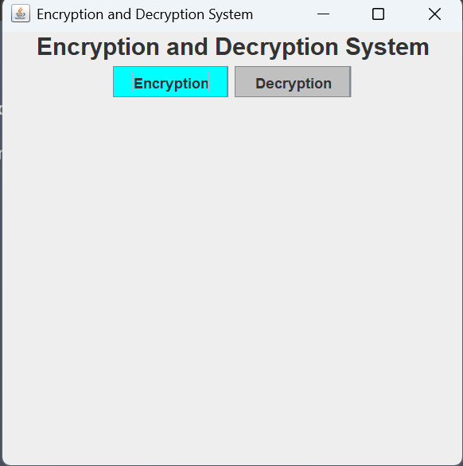
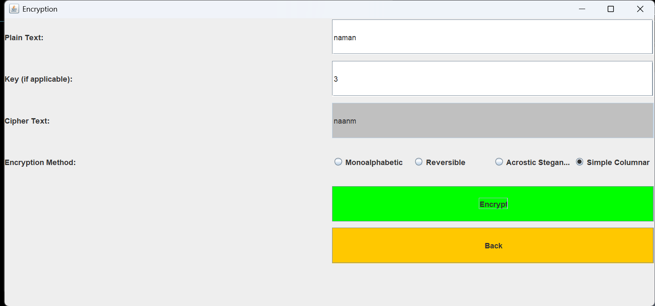
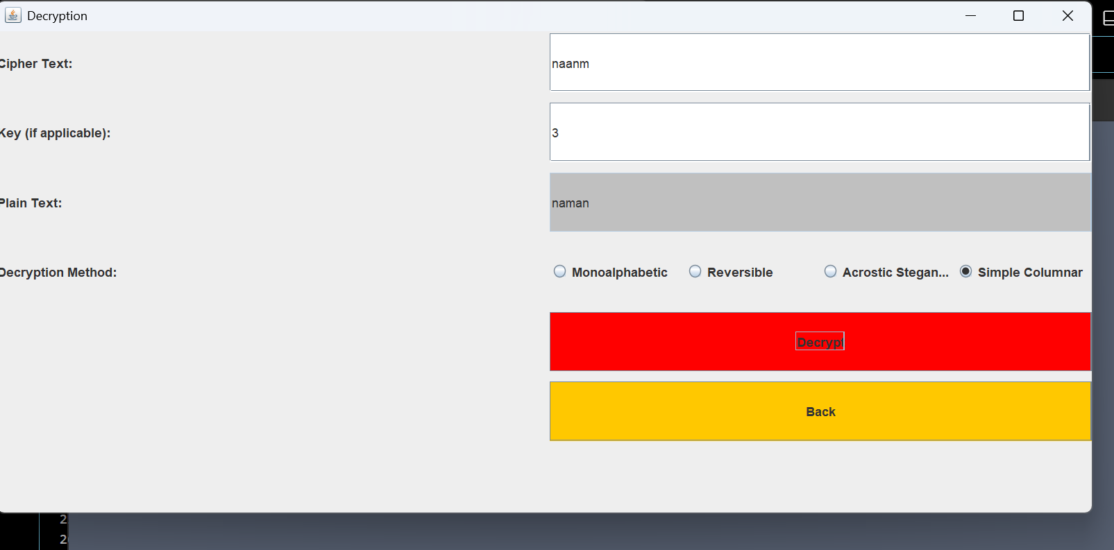
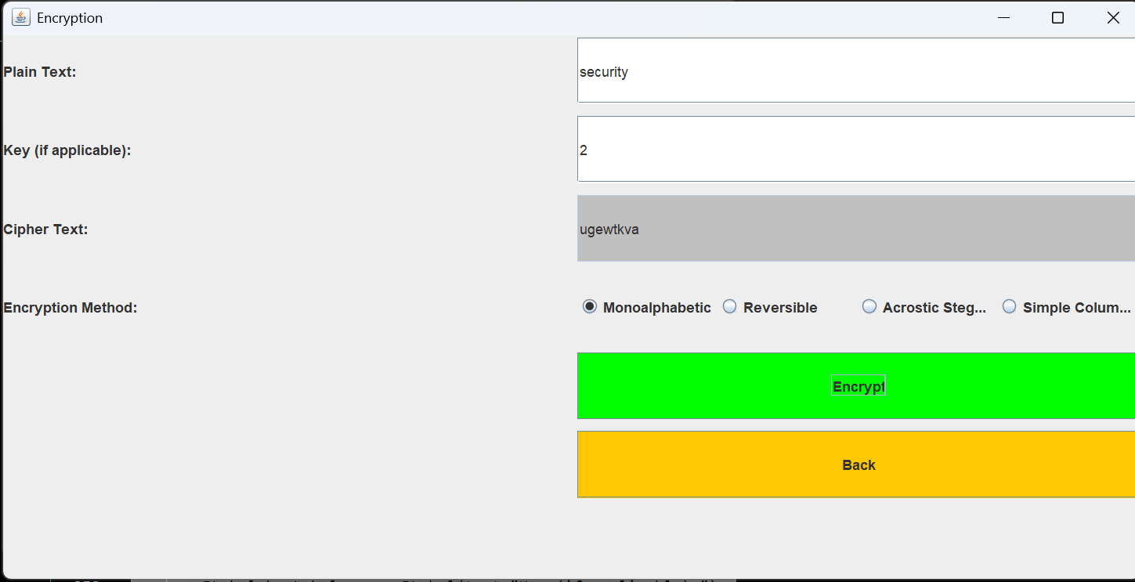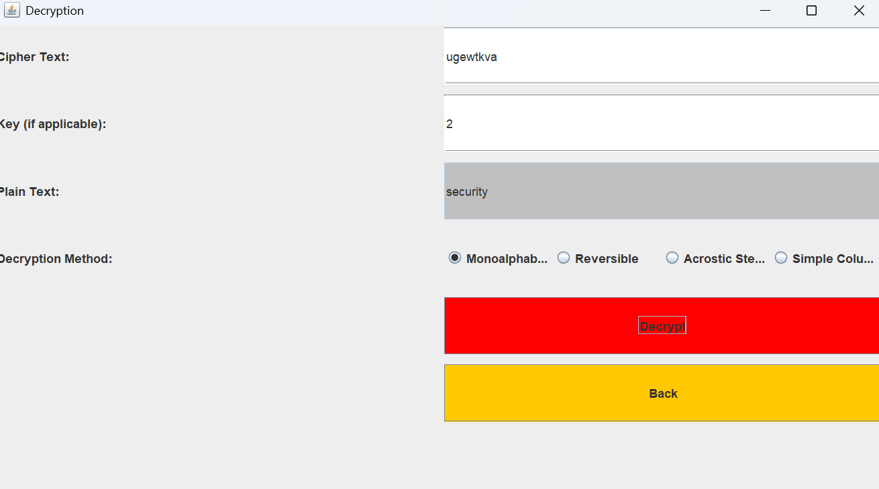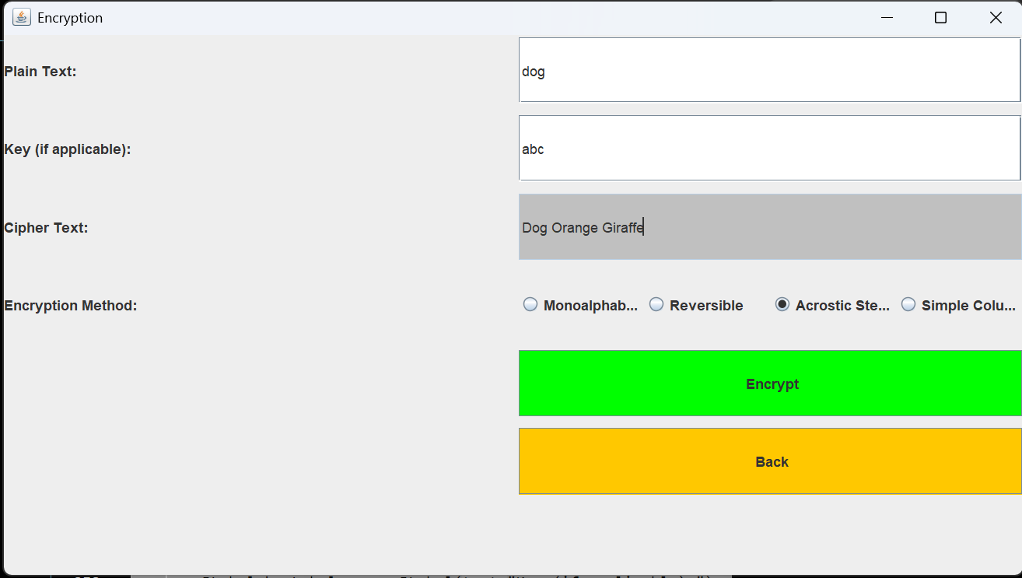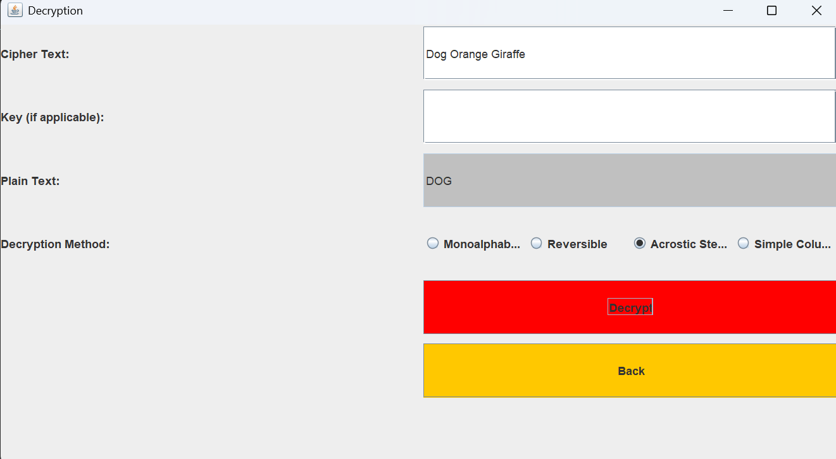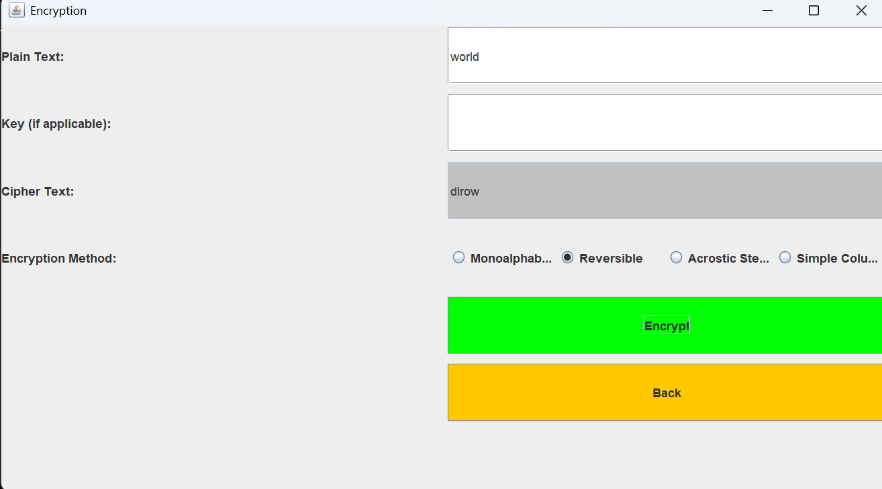
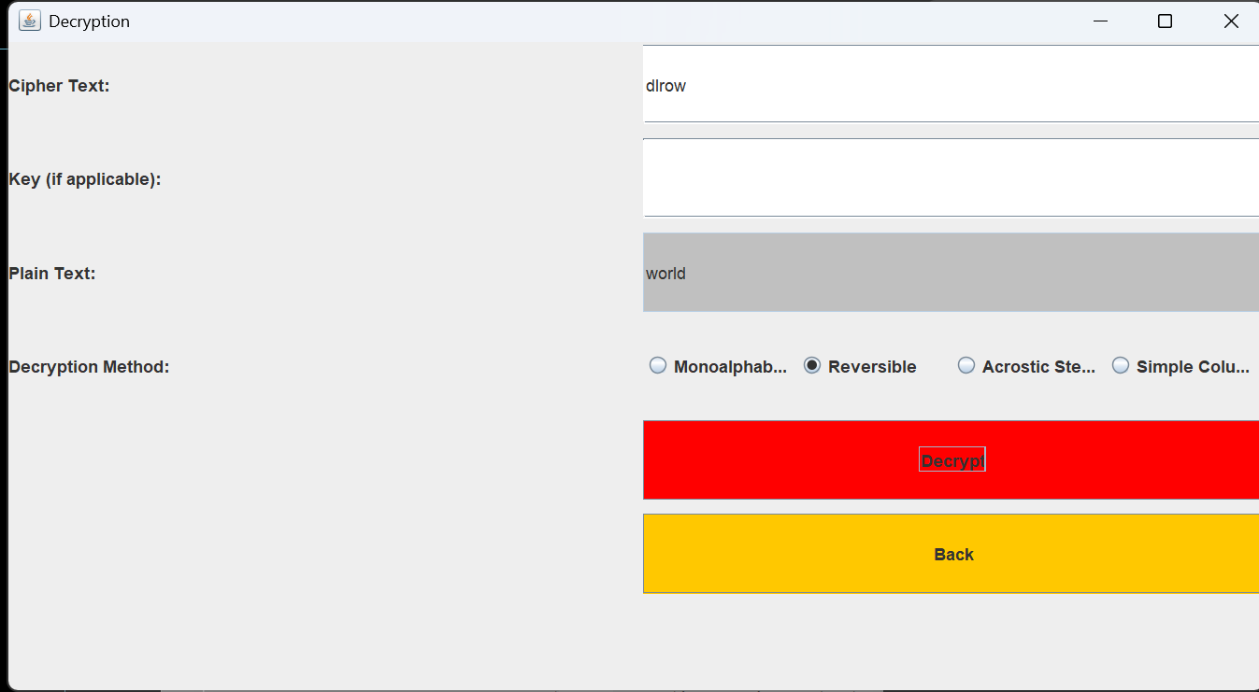

CONCLUSION
In this microproject, we explored and successfully implemented four different encryption and decryption methods—Monoalphabetic Substitution, Reversible Encryption, Acrostic Steganography, and Simple Columnar Transposition—using a Java-based GUI application. These techniques provided a broad understanding of classical cryptographic and steganographic methods, offering both theoretical and practical insights.

